https://www.youtube.com/watch?v=b7oUQJc-P5Y
Intro to Agent Mode in Visual Studio
Normal co-pilot chat
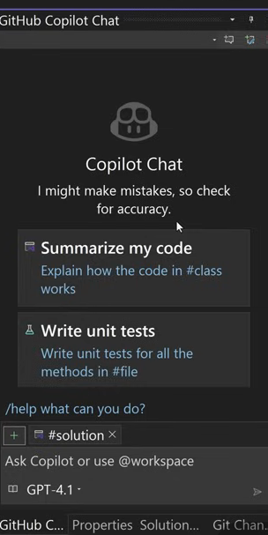

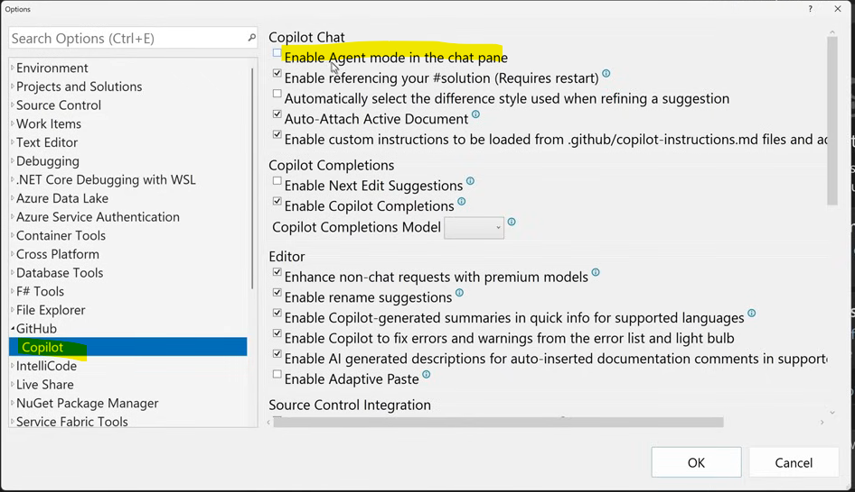

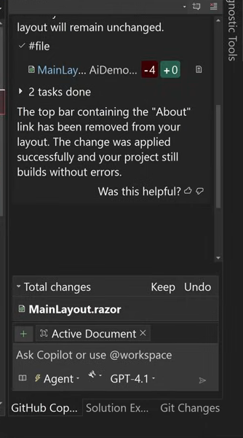

It can be agent or ask , in the co-pilot

Sample is a blazer application

Prompts
- I don’t like the top bar on my side (where it say “About”) , can you remove the entire bar?
- I want to change the color theme to user colors #abc , #cde , #efg
- Add a dapper nuget package to the solution

Points
- We can run the changes , before accepting the changes suggested by the co-pilot

https://www.youtube.com/watch?v=YObqpmGYguE

Agent Mode and the Profiler Agent in Visual Studio

Prompts
- Implement the #Houseglass.png for a loading state before the radio is playing (LLM Claude Sonnet 4.5 )
- Write the code , I will provide the icon file later
- Try to build
- Reference files or anything by adding # (assests)
- With / (action) we will doc, explain , fix , help , optimize , tests in Agent mode
- @ is used for referencing different agents (Debugger , GitHub , Profile , Test , VS , Workspace)
- @Profiler help me optimize the memory usage of grab frame
- Apart from Profile agent we also have debugger agent

Points
- Keep or Undo changes suggested by co-pilot

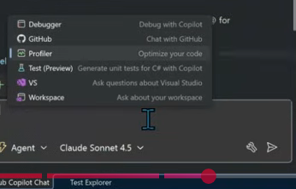

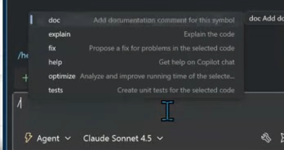

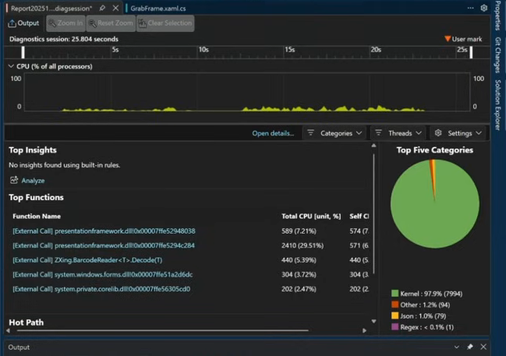

Prompts
- Create a new web api application using ast.net core to perform crud operations . Make sure you use EF core in memory . Create a new app in 0004 folder
- Please add custom suggestions and suggest new requirements , to a new section of the #readme.md under the feature backlog
- What workspace it is working under
- We can ask copilot for the execution pan , before proceeding with the changes
- Claude Sonnet 4.5 – premium model

Points
- Free models are slow
- For complex items better to go with premium models
- Some scenarios execution plan in free model , and execution in payed models

Cursor has its own IDE developed as a fork on top of visual studio code
- More quality of prompt you give , better the code
- It is similar to the chat/agent window we get for co-pilot

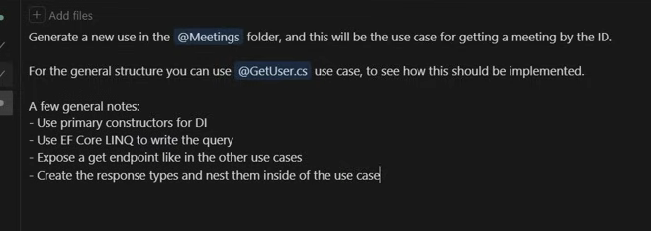

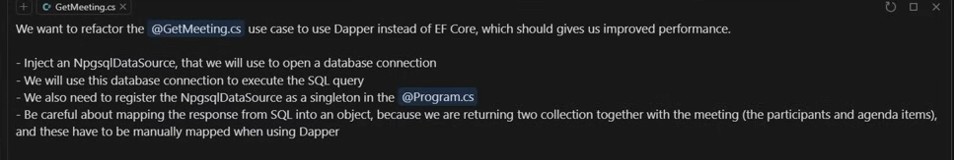

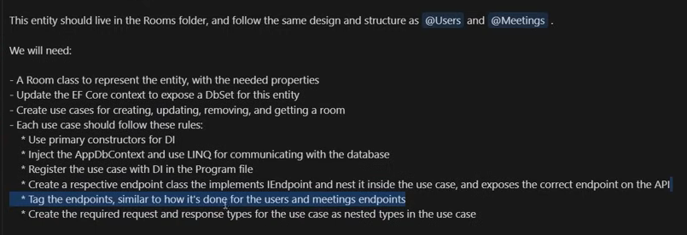

Prompts
- You can add attachment (image file) and write the wordings
- Ex , update the page to reflect the design as mentioned in the attachment
- We can also add the custom instructions for co-pilot

